KEJEBIL R/C BASIC SCHOOL

TERM THREE

MATHEMATICS --- JHS 1

WEEKLY LESSON PLAN

WEEK 5

Name:…………………………………………………………………………………………..

Week Ending: 22/06/2026 |  | MONDAY  18/05/2026 |  | Subject: Mathematics
Duration: 50MINS |  |  |  | Strand: Geometry & Measurement
Class: B7 |  | Class Size: 43 |  | Sub Strand: Bearing
Content Standard:  B7.3.2.3 Demonstrate understanding of bearings, vector and its components using real life cases |  |  | Indicator:  B7.3.2.3.1 Describe the bearing of a point from another point |  |  | Lesson:  1 of 2
Performance Indicator:  Learners can describe the bearing of a point from another point |  |  |  | Core Competencies:  Communication and Collaboration (CC) Critical Thinking and Problem solving (CP)
References: Mathematics Curriculum Pg. 58
Phase/Duration | Learners Activities |  |  |  | Resources
PHASE 1: STARTER  5 MINUTES | Revise with learners on the previous lesson.  Share performance indicators and introduce the lesson.
PHASE 2:  NEW LEARNING  40 MINUTES | Start the lesson by calling learners to give direction to places in the community making reference to the cardinal points. That is North, South, East and West.  Brainstorm learners for the meaning of Bearing.  Bearings give directions in terms of an angle.  Call 2 students to the front of the class, placing them far apart.  Ask learners to talk about the distance between the students in terms of angle.  Write on the board Kofi 50⁰ Kwame.  Guide learners to read it as “from Kofi measures 50 towards Kwame”  Guide learners to draw a diagram to explain that.  Kofi  Kwame  50⁰  Introduce learners to the three figure bearings.  Draw the diagrams and guide learners to use the three figure bearing to describe them.  N  Ship  99⁰  N  town  9⁰  In the first diagram, 9⁰ gives 009⁰ and 99⁰ gives a bearing 099⁰.  Guide learners to use protractor to find the marked angles. For each diagram write the three-digit bearing.  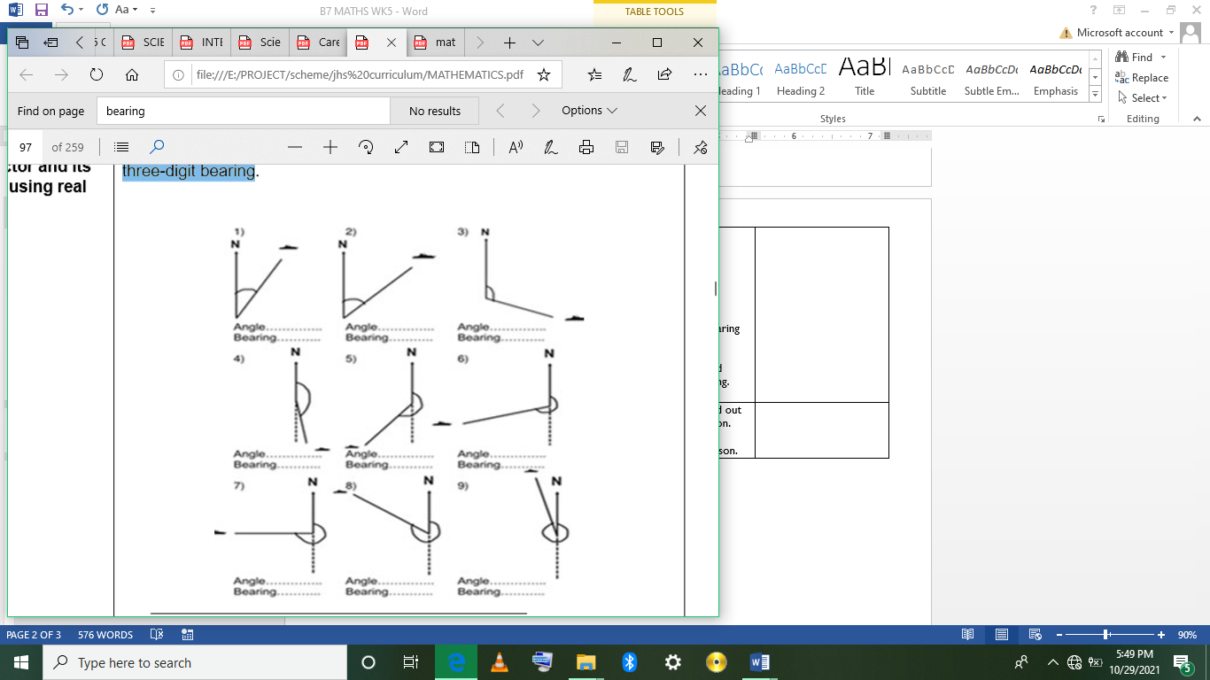  Learners recognize true bearings as the angle measured in the clockwise direction from the North.  Guide learners to express the following vectors graphically and measure each angle.  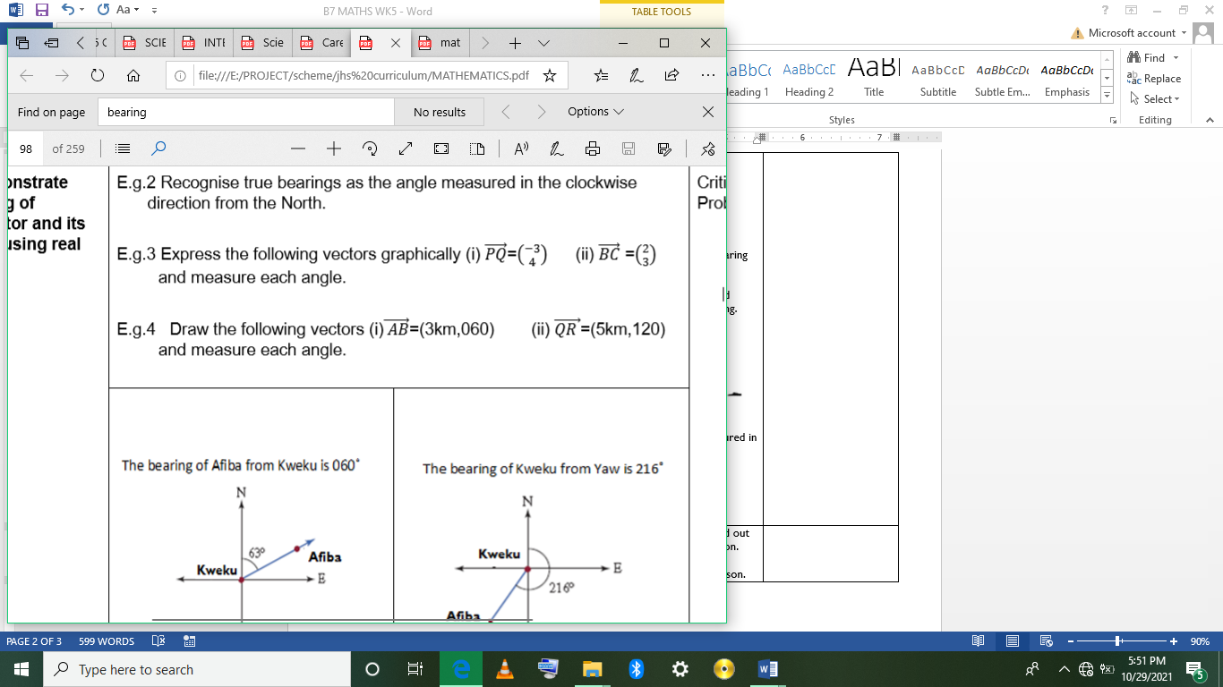  In pairs learners draw the following vectors and measure each angle.  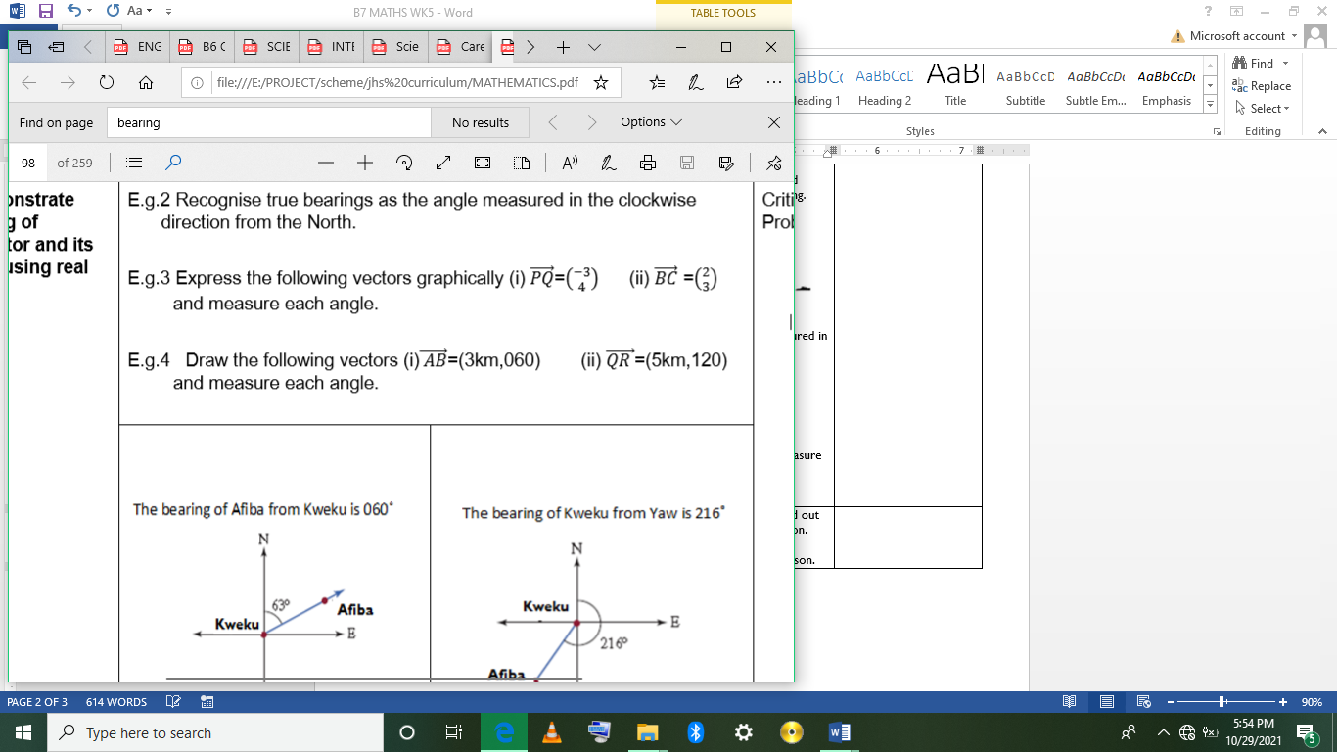  Assessment  State the bearing of the point kweku in each of the diagram.  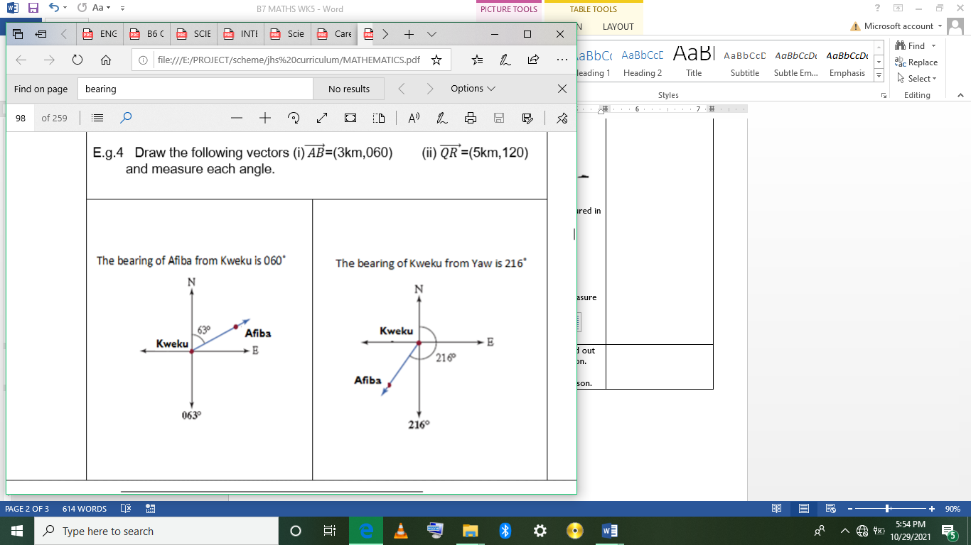 |  |  |  | Square grid paper, Ruler, grid paper or Geodot paper
PHASE 3: REFLECTION  5 MINUTES | Use peer discussion and effective questioning to find out from learners what they have learnt during the lesson.  Take feedback from learners and summarize the lesson.

Week Ending: 22/06/2026 |  | TUERSDAY  19/05/2026 |  | Subject: Mathematics
Duration: 60MINS |  |  |  | Strand: Geometry & Measurement
Class: B7 |  | Class Size: 43 |  | Sub Strand: Back Bearing
Content Standard:  B7.3.2.3 Demonstrate understanding of bearings, vector and its components using real life cases |  |  | Indicator:  B7.3.2.3.2 Explain how to find the back bearing when the direction of travel has a bearing which is less than 180˚ and/ or greater than 180˚ |  |  | Lesson:  2 of 2
Performance Indicator:  Learners can find the Back Bearing when the direction is either greater or less than 180. |  |  |  | Core Competencies:  Communication and Collaboration (CC) Critical Thinking and Problem solving (CP)
References: Mathematics Curriculum Pg. 58
Phase/Duration | Learners Activities |  |  |  | Resources
PHASE 1: STARTER  5 MINUTES | Revise with learners on the previous lesson.  Share performance indicators and introduce the lesson.
PHASE 2:  NEW LEARNING  40 MINUTES | Draw these diagrams on the and ask learners in groups to solve them. Call groups to present their answers on the board.  60⁰  20⁰  48⁰  Introduce learners to the back bearing. Explain to learners that bearings are useful if you are heading out to someplace and then returning along the same line of travel.  - When the direction of travel bearing is less than 180 degrees.  Example your bearing is 50, then your back bearing is 230.  Back bearing = (180 + direction of travel bearing)  BB = (180 + 50) = 230  BB  180  Direction  of travel  50  Magnitude North  BB  Back bearing = (180 + bearing)  - When the direction of travel bearing is greater than 180.  For example if your bearing is 230, then your back bearing is 50 degrees.  BB = B -180  BB = 230 – 180 = 50  BB  180  Direction  of travel  50  Magnitude North  BB  In pairs, learners solve these examples  - If the bearing of Y from X is 060, find the bearing of X from Y.  - If the bearing of P from Q is 245, find the bearing of Q from P.  Assessment  - If the bearing of a point Q from another point P is 040, find the bearing of P from Q.  - If the baring of P from Q is 145, find the baring of Q from P.
PHASE 3: REFLECTION  5 MINUTES | Use peer discussion and effective questioning to find out from learners what they have learnt during the lesson.  Take feedback from learners and summarize the lesson. |  |  |  | Graph sheet, Protractor, Ruler

Week Ending: 22/06/2026 |  | THURSDAY  21/05/2026 |  | Subject: Mathematics
Duration: 60MINS |  |  |  | Strand: Geometry & Measurement
Class: B7 |  | Class Size: 43 |  | Sub Strand: Scalar and Vector Quantities
Content Standard:  B7.3.2.3 Demonstrate understanding of bearings, vector and its components using real life cases |  |  | Indicator:  B7.3.2.3.3 Distinguish between scalar and vector quantities |  |  | Lesson:  1 of 2
Performance Indicator:  Learners can distinguish between scalar and vector quantities |  |  |  | Core Competencies:  Communication and Collaboration (CC) Critical Thinking and Problem solving (CP)
References: Mathematics Curriculum Pg. 70
Phase/Duration | Learners Activities |  |  |  | Resources
PHASE 1: STARTER  5 MINUTES | Revise with learners on the previous lesson.  Share performance indicators and introduce the lesson.
PHASE 2:  NEW LEARNING  40 MINUTES | Brainstorm learners for the meaning of scalar quantity and vector quantity.  A vector quantity is any quantity which has both magnitude and direction. Examples are displacement, acceleration, momentum, velocity, etc. Whiles A scalar quantity has magnitude only. Examples are time, speed, distance, mass, etc.  Draw on the board, a representation of a vector.  The directed line segment XY is a  vector. The length of the line segment  XY is the magnitude of the vector and  the direction is represented by the  bearing 045⁰.  X  Y  45⁰  Have learners read on the internet for more information on scalar quantity and vector quantity.  Put learners into groups of five. Have them group these examples under scalar quantity and vector quantity, weight, force, velocity time, speed, distance, mass, volume, energy, work momentum.  Guide learners to identify a vector as a movement (distance) along a given bearing.  $\vec{AB}$ = $\left({a \atop b}\right)$  POSITION VECTORS  They are denoted by small  letters printed in bold type.  FREE VECTORS  They are denoted by a pair  of block letters and an arrow.  Write this on the board and guide learners to interpret it.  $\vec{AB}$ = $\left({a \atop b}\right)$. The horizontal component a, is measured along the x-axis and the vertical component, b is measured along the y-axis from A to B.  $\vec{AB}$ = $\left({4 \atop 5}\right)$. Means a particle is moved 4units to the right and 5units upwards from point A to another point B.  In groups, learners interpret the following vectors.  $\vec{XY}$ = $\left({-3 \atop 4}\right)$, $\vec{PQ}$ = $\left({3 \atop 6}\right)$, $\vec{MN}$ = $\left({2 \atop -3}\right)$.  Guide learners to represent vectors graphically.  E.g. $\vec{XY}$ = $\left({-3 \atop 4}\right)$,  -4 -3 -2 -1 0 1 2 3  4  3  2  1  5  X  Y  E.g. 2. $\vec{TS}$ = (6km,145˚).  N  T  S  6km  145˚  Assessment  Express the following graphically;  1) $\vec{PQ}$ = $\left({3 \atop 6}\right)$, 2) $\vec{BC}$ = $\left({2 \atop -3}\right)$.  3) $\vec{AB}$ = (3km, 060)  4) $\vec{QR}$ = (5km, 120).
PHASE 3: REFLECTION  5 MINUTES | Use peer discussion and effective questioning to find out from learners what they have learnt during the lesson.

